Practical Laboratory 1

Part A Prepare VirtualBox
- Shut down icdfa-nslab-client-v1 and icdfa-nslab-firewall-v1 completely. Do not change network adapters while a VM is running or saved.
- Select icdfa-nslab-firewall-v1, open Settings, and choose Network.
- For Adapter 1, select Enable Network Adapter and set Attached to NAT. Confirm Cable Connected is selected.
- For Adapter 2, select Enable Network Adapter and set Attached to Internal Network. Enter ICDFA-LAN as the name and confirm Cable Connected is selected.
- Disable any unused Adapter 3 or Adapter 4 for this reduced two-VM laboratory.

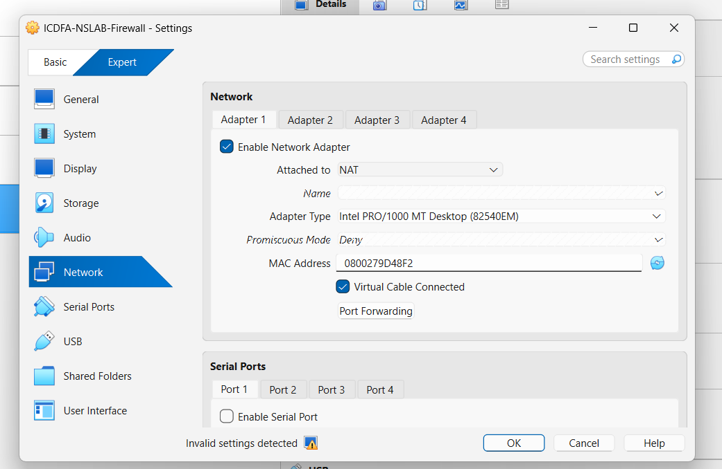

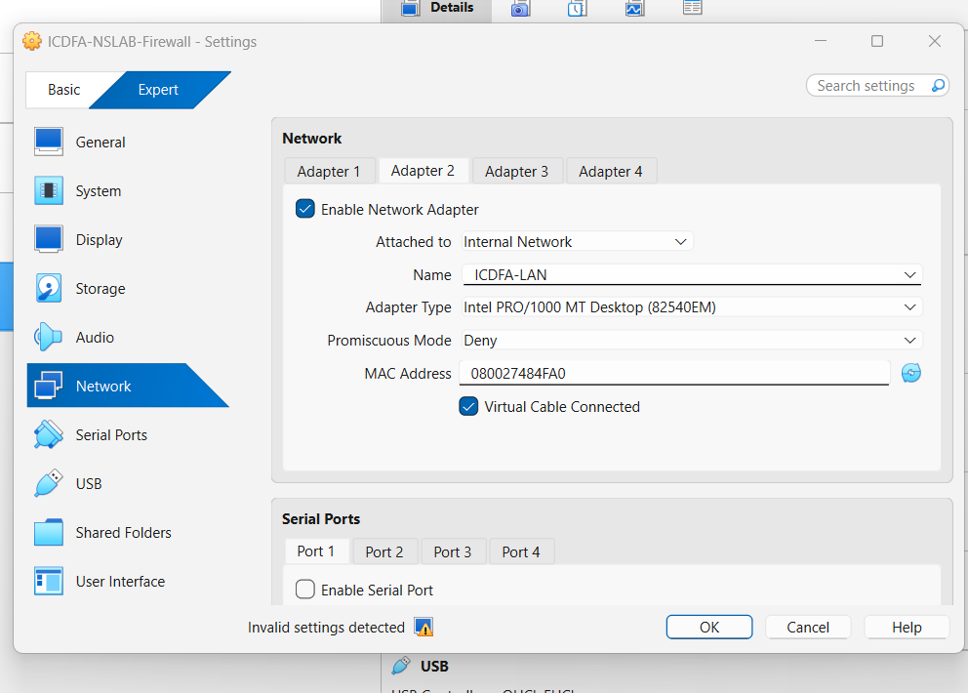

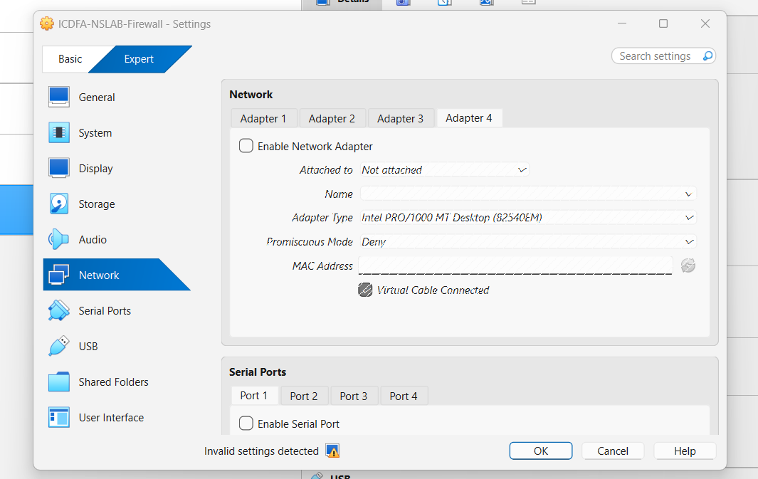
- Shut down icdfa-nslab-client-v1 and icdfa-nslab-firewall-v1 completely. Do not change network adapters while a VM is running or saved.
- Select icdfa-nslab-firewall-v1, open Settings, and choose Network.
- For Adapter 1, select Enable Network Adapter and set Attached to NAT. Confirm Cable Connected is selected.
- For Adapter 2, select Enable Network Adapter and set Attached to Internal Network. Enter ICDFA-LAN as the name and confirm Cable Connected is selected.
- Disable any unused Adapter 3 or Adapter 4 for this reduced two-VM laboratory.

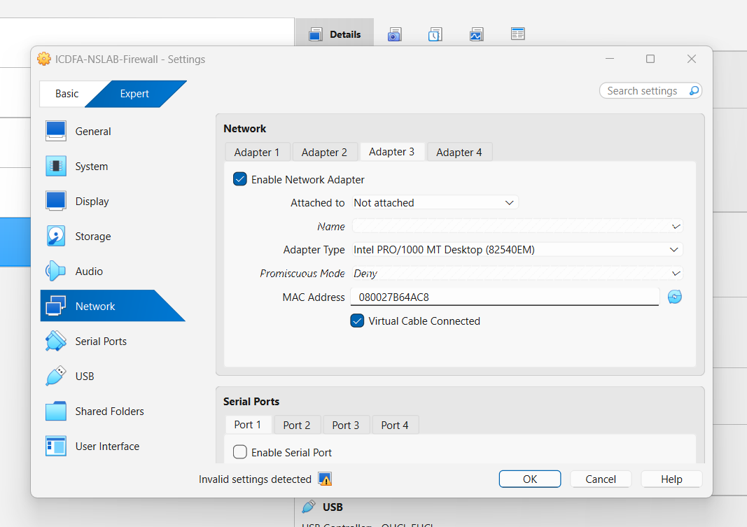

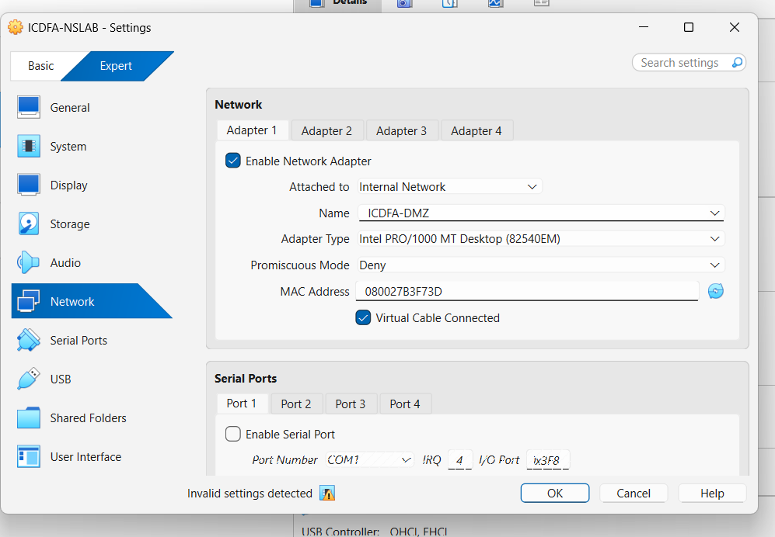

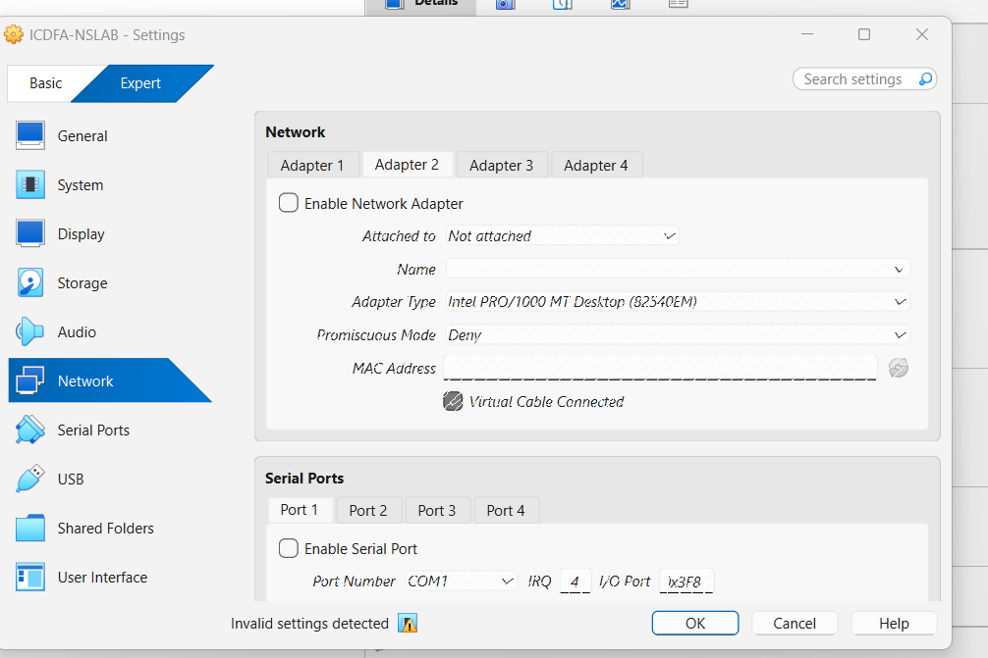

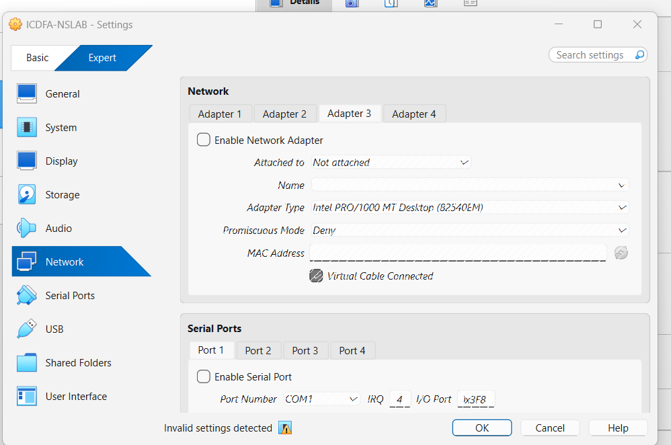

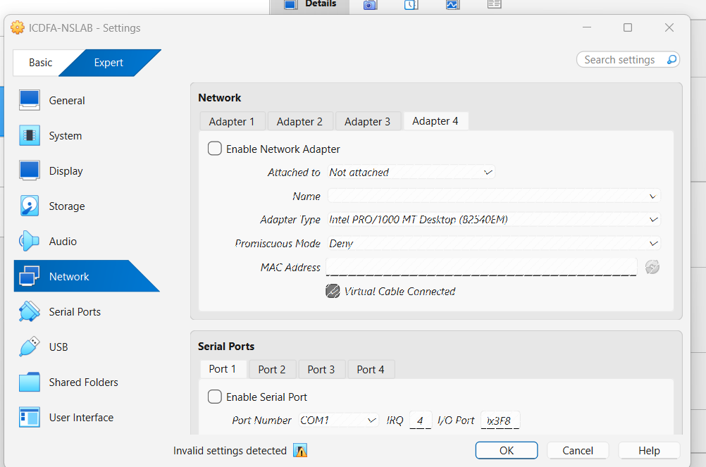

Part B Verify OPNsense interfaces
- Start icdfa-nslab-firewall-v1 and wait for the OPNsense console menu.
- Start icdfa-nslab-firewall-v1 and wait for the OPNsense console menu.
- Confirm that one interface is marked WAN and the second is marked LAN.
- Confirm that the LAN address is 10.10.10.1/24. If this address is already displayed, do not change it.
- If the LAN address is absent or different, choose option 2 Set interface IP address, select LAN, enter 10.10.10.1, use prefix length 24, and do not enter an upstream gateway for LAN.
- When asked about DHCP on LAN, enable it with a range of 10.10.10.100 to 10.10.10.200.
- Do not configure a gateway on the LAN interface. The WAN interface should obtain its address automatically through DHCP.

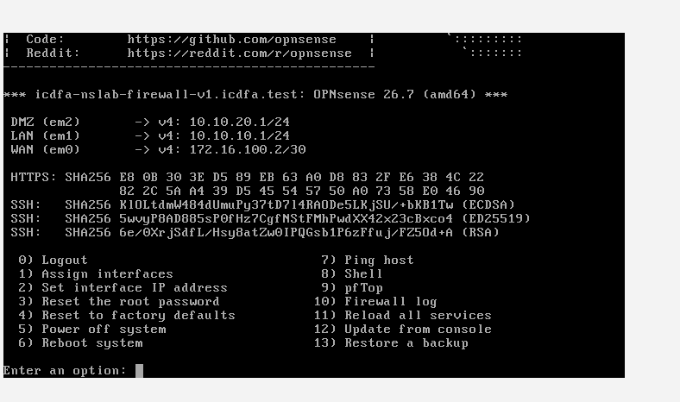

Part C Verify Ubuntu addressing
- Start icdfa-nslab-client-v1 only after icdfa-nslab-firewall-v1 is ready.
- Open Terminal and display the IPv4 interfaces.
ip -4 -br address
Record the active interface name and IPv4 address. The address should be inside 10.10.10.0/24 and must not be 10.10.10.1.
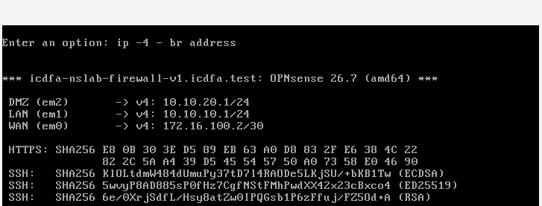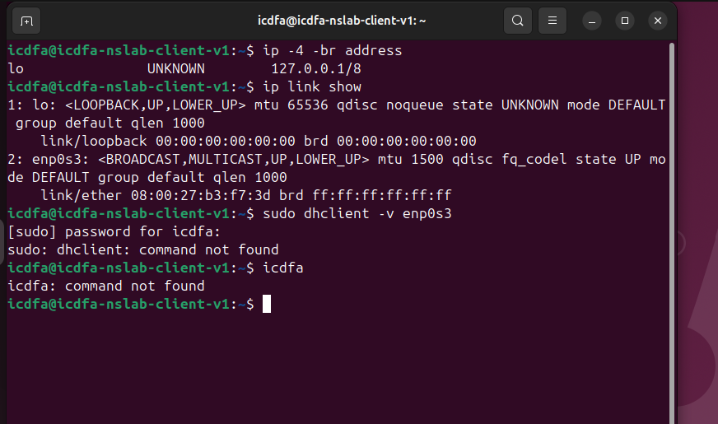
The Ubuntu client contains an active network interface named enp0s3. The interface is operational but does not currently have an IPv4 address assigned. Only the loopback interface (127.0.0.1/8) is displayed, indicating that the client has not yet obtained an address from the DHCP server on the 10.10.10.0/24 LAN.
ip route
Confirm that the default route points to 10.10.10.1. Then review the DNS configuration.
resolvectl status

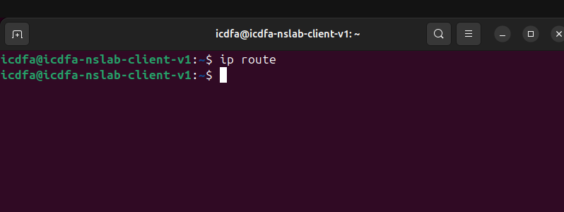
The command ip route was executed on the Ubuntu client. No routing entries were displayed. This indicates that the client has not obtained an IPv4 configuration and therefore does not have a default route. As a result, the default gateway cannot be confirmed as 10.10.10.1 at this stage. Earlier checks showed that interface enp0s3 was disconnected and had not received an address from the DHCP server.
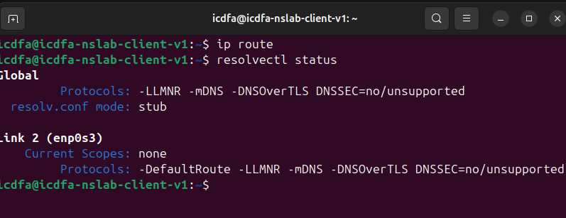
The command ip route returned no routing entries. Therefore, the Ubuntu client does not currently have a default route and the default gateway cannot be confirmed as 10.10.10.1. The command resolvectl status showed that interface enp0s3 has Current Scopes: none and no DNS configuration. This indicates that the client has not received network settings from DHCP and is not connected to the LAN correctly.
The evidence points to the Ubuntu VM's enp0s3 interface being disconnected from the firewall's LAN network, so DHCP information (IP address, gateway, and DNS) has not been obtained.

Part D Perform connectivity tests
Run the tests in the sequence below. Do not skip directly to the internet test because each command verifies a different layer.
Test | Command | Expected result | What it proves
1 | ping -c 4 10.10.10.1 | Replies received | Ubuntu can reach the firewall LAN interface
2 | ping -c 4 1.1.1.1 | Replies received | Routing and outbound NAT are working
3 | getent hosts opnsense.org | One or more addresses returned | DNS name resolution is working
4 | curl -I https://opnsense.org | HTTP response headers | TCP, TLS and web connectivity are working

Open a browser and visit https://10.10.10.1. Accept the laboratory self-signed certificate warning only for this authorised local firewall. Sign in and capture the dashboard showing the WAN and LAN status.
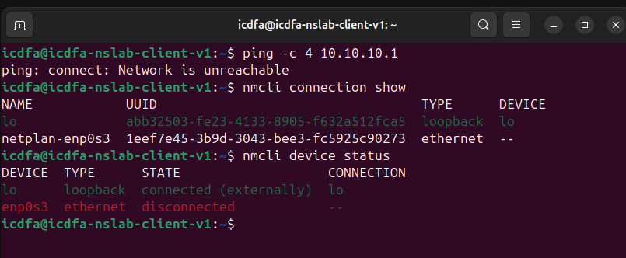

Part E Observe packets in Wireshark
- Open Wireshark on Ubuntu.
- Select the active Ethernet interface carrying the 10.10.10.x address and begin capture.
- In Terminal, repeat ping -c 4 10.10.10.1 and getent hosts opnsense.org.
- Stop the capture after the commands finish.
- Apply each display filter below and inspect the matching packets.
- E3. OPNsense console or dashboard showing WAN and LAN addresses.
- E4. Ubuntu output from ip -4 -br address and ip route.
- E5. Successful local gateway, internet and DNS tests.
- E6. Wireshark ARP, ICMP and DNS views with the filters visible.
- E7. A short paragraph explaining why icdfa-nslab-client-v1 uses 10.10.10.1 as its default gateway.
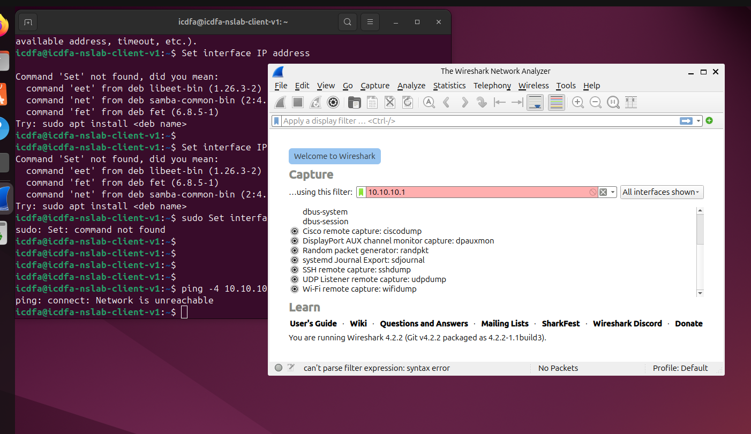

Completion questions
- What is the difference between the OPNsense WAN and LAN interfaces?
- Why must both internal adapters use the same VirtualBox network name?
- What information does the default route provide to Ubuntu?
- Which packet exchange allows Ubuntu to learn the firewall MAC address?
- Why does a successful ping to 1.1.1.1 not automatically prove that DNS is working?

1. What is the difference between the OPNsense WAN and LAN interfaces?
The WAN (Wide Area Network) interface connects the firewall to external networks, such as the Internet, while the LAN (Local Area Network) interface connects the firewall to the internal network and local devices. The WAN receives and sends traffic to outside networks, whereas the LAN provides connectivity and services to internal hosts.

2. Why must both internal adapters use the same VirtualBox network name?
Both internal adapters must use the same VirtualBox network name so that they are connected to the same virtual network segment. This allows the Ubuntu client and the OPNsense LAN interface to communicate directly, exchange data, and use services such as DHCP and DNS.

3. What information does the default route provide to Ubuntu?
The default route tells Ubuntu where to send packets that are destined for networks outside its local subnet. In this lab, the default route should point to the firewall IP address 10.10.10.1, which acts as the gateway to other networks and the Internet.

4. Which packet exchange allows Ubuntu to learn the firewall MAC address?
Ubuntu learns the firewall's MAC address through the Address Resolution Protocol (ARP) process. Ubuntu sends an ARP Request asking for the MAC address associated with the firewall's IP address, and the firewall replies with an ARP Reply containing its MAC address.

5. Why does a successful ping to 1.1.1.1 not automatically prove that DNS is working?
A ping to 1.1.1.1 only verifies IP connectivity and routing because it uses a numeric IP address. DNS is not required for this test. DNS functionality is only confirmed when a hostname, such as opnsense.org, can be successfully resolved to an IP address.

